DBMS Lab Assignment 11
Neeti Kurulkar
MapReduce using MongoDB

Queries:
- Create Collection

- Insert Values
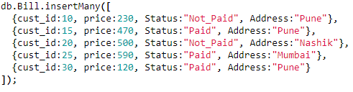
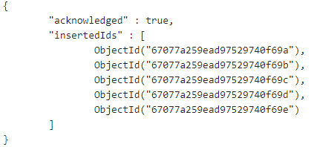

- Display Values
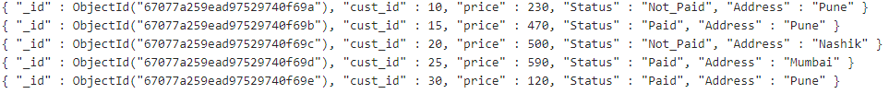

- MapReduce
